JAVA ASSIGNMENT-9 (19/11/2018)
1)
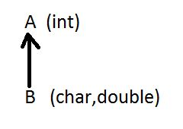
package raj;
class R
{
R(int x)
{
System.out.println("A class constructor is:"+x);
}
}
class S extends R
{
S(char y, double z,int x)
{
super(x);
System.out.println("B class constructor is: char "+y);
System.out.println("B class constructor is: double "+z);
}
}
public class Singlelevel1 {

public static void main(String[] args) {
S obj=new S('a',22.22,5);

}

}

Output:
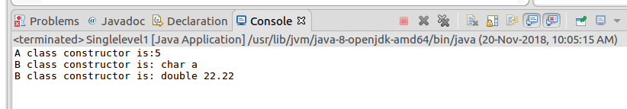

2)
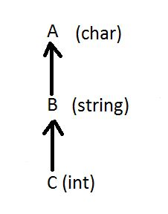

package raj;
class T
{
T(char ch)
{
System.out.println("T is class constructor and value is : "+ch);
}
}
class U extends T
{
U(String s,char ch)
{
super(ch);
System.out.println("U is class constructor and value is :"+s);

}
}
class V extends U
{
V(int x,String s,char ch)
{
super(s,ch);
System.out.println("V is class constructor and value is : "+x);

}
}
public class Multilevel1 {

public static void main(String[] args) {

V obj=new V(5,"abc",'d');
}

}

Output:
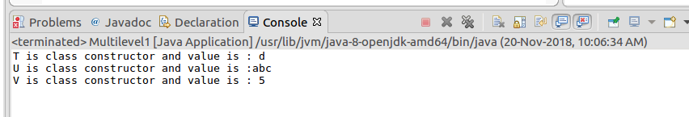

3)
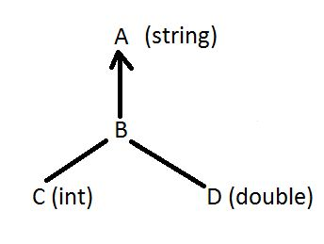

package raj;
class M
{
M(String s)
{
System.out.println("M is class constructor and value is: "+s);
}
}
class N extends M
{
N(String s)
{
super(s);
}
}
class O extends N
{
O(int x,String s)
{
super(s);
System.out.println("N is class constructor and value is : "+x);
}
}
class P extends N
{
P(double d,String s)

{
super(s);
System.out.println("O is class Constructor and value is: "+d);
}
}
public class Heirarchical1cons {

public static void main(String[] args) {
O obj1=new O(5,"raj");
P obj2=new P(22.22,"raju");

}

}

Output:
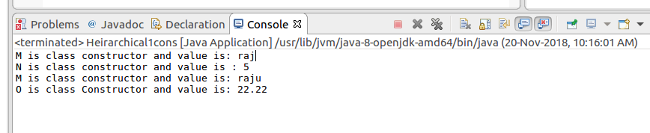

4)Write a java program to compare two strings character by character and print the location of characterwhich is matched.

package raj;

public class Compare2str {

public static void main(String[] args) {
String s1="rajashekar";
String s2="mekala";
for(int i=0;i<s2.length();i++)
{
if(s1.charAt(i)==s2.charAt(i))
{
System.out.println("the character matched is "+s1.charAt(i)+ " and at "+i);
}
}

}

}

Output:
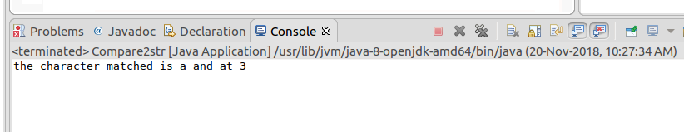

5)Write a java program to find the no of time the string “there” repeated in the following string---------(when there is a will, there is a way)

package raj;

public class Stringrep {

public static void main(String[] args) {

int c=0;
String s="when there is will there is a way";
String ar[]=s.split(" ");
for (int i = 0; i < ar.length; i++) {
if(ar[i].equals("there"))
{
c++;
}
}
System.out.println("No Of Times Repeated:"+c);
}

}
Output:

